TITLE: Practical Test Report

Industrial Control Systems - Practical test written Report

Name: Pankaj Singh Rawat

Student Number: C00290835

Date: 18.12.2022.

# Executive summary

P&ID, short for piping and instrumentation diagram, is a drawing in the process industry. It shows the piping of the process flow together with the installed equipment and instrumentation. These two templates are producing PID and wastewater treatment PID. Though seems very complicated, they were finished in a short time.

This report discusses the importance of understanding the process being controlled in order to design an effective control system. The specific process being described is a water treatment plant, which can involve a range of physical, chemical, and biological treatment methods and technologies to remove pollutants from water. The plant in question is divided into three processing areas, each with its own specific equipment. The control philosophy for the plant involves avoiding overfilling or underfilling tanks and using interlocking to stop pumps and agitators when necessary. Structured testing is also mentioned as a way to demonstrate and document the operation of the system's software and identify and address any deficiencies.

In summary, the purpose of this assignment is to design a control system for a water treatment plant. The plant consists of three separate processing areas, each containing various equipment for physical, chemical, and biological treatment of water. The control system will ensure that tanks in the process are not overfilled or underfilled, which could cause problems like spillages or pump failure. Testing will be conducted to verify the operation of the system software and any deficiencies will be documented and addressed.

Keywords: P&ID (piping and instrumentation diagram), Programmable logic controllers, Process Industry, wastewater treatment.

# Declaration of originality

I certify that the material I submit here for assessment is entirely my own work and has not been taken from the work of others save and to the extent that such work has been cited and acknowledged within the text of my work. I acknowledge that submission of this work constitutes the full knowledge that if found to be in breech, as the person who copied or allowed their work to be copied, I may receive a grade of 0 for this submission and may be subject to further disciplinary action.

Pankaj Singh Rawat 19 Dec 2022

________________________________ _______________________

Name Date

Contents

Executive summary 2

Declaration of originality 2

Table of figures 4

Introduction 5

Problem statement 5

Objective 5

Literature review 6

Discussion 13

[SIMANTIC S7-1200:The Modular Mini-PLC 15](#_Toc115971258)

TIA Portal: Portal view and Project view 17

Results 26

Analysis 28

Conclusion 20

HMI Portion 20

PLC Portion 23

References  28

Appendices 29

Appendix 1: Drawings and schematics 29

P&ID 29

Appendix 2: Software 30

HMI 30

Appendix 3: Hardware 32

PLC 33

# 

# Table of figures

Figure 1: P&ID of a wastewater treatment plant

Figure 2: Device symbol in the P&ID drawing

Figure 3: Conduit symbols and connections

Figure 4: Tank symbol

Figure 5: Heat Exchanger symbol

Figure 6: Pumps symbol

Figure 7: Instrumentation symbol

Figure 8: Valve symbol

.

# Introduction

The purpose of this report is to explore the operational requirements of a water treatment plant, which is used to remove contaminants from process water for safe discharge or reuse. To gain a deeper understanding of the processes and equipment involved, the researcher studied multiple papers on the subject. Some characteristics that identify a plant as a water treatment facility include the chemicals used, such as Sodium Carbonate and Limestone flour or calcium carbonate, and the layout of the plant, which includes tanks for filling and draining with agitation. Efficient pumps and piping are necessary for the plant to function properly, and interlocking is used to prevent issues like overfilling or underfilling tanks and pump failure.

The control system for a water treatment plant must ensure that tanks in the process are not overfilled or underfilled, as this can cause problems such as spillages or pump failure. To design an effective control system, it is necessary to understand the process that will be controlled, which includes the use of physical, chemical, and biological treatment methods. In this assignment, a P&ID drawing of a typical plant process was provided, and research was conducted to gain a deeper understanding of the process. It was determined that the process is a water treatment plant that may be required due to the type and concentration of contamination, site location, and regulatory requirements. The plant consists of three separate processing areas, each containing various equipment. The control philosophy for the plant is detailed in the Control and Interlock Matrix, which utilizes interlocking on the control logic to prevent overfilling or underfilling of tanks. Structured testing will be conducted to verify the operation of the system software, and any deficiencies found during testing will be documented and addressed on a planned basis.

## Problem statement

The objective of this project is to create a control system for a water treatment plant that includes a programmable logic controller (PLC) for fill and drain control. The human-machine interface (HMI) screen will serve as the operator interface for the control system.

## Objective

## The initial steps in the methodology for this report was to do broad industry research to better understand the issues the sector is now facing. The study was then finished up with its practical component. This involves doing research on the relevant parts needed to finish the project's scope. The project employed a Siemens PLC for control and a Siemens HMI for visualization. The design process began by listing all of the plant equipment in an Excel spreadsheet and assigning ID numbers and group numbers to each piece of equipment. Next, the PLC tag structure was created by using data blocks to assign tags for each device. The PLC code and HMI tags were then developed, followed by the creation of screens for each area that could be animated. This series of steps ensured that the control system was properly configured, and that the operator could easily monitor and control the plant through the HMI interface.

# Literature review

1. **Concepts: -**

A Piping and Instrumentation Diagram (P&ID) is a graphical representation of a production process that shows the locations and connections of all equipment, pipes, and other elements in a specific area of a factory. P&ID diagrams are useful for operators, workers, and engineers to understand the principles of the system and the equipment it contains. The basic elements of a P&ID diagram include pipelines, measuring and control devices (such as sensors and valves), and machines. To interpret a P&ID diagram, it can be helpful to divide the master diagram into smaller areas and use an object as a reference point to trace the direction of pipelines to other devices.

Fig. 1. **P&ID of a wastewater treatment plant**

There are several reasons for using P&ID diagrams in engineering projects:

* To gain a better understanding of the design conditions of the project.
* To efficiently operate, maintain, and repair the system.
* To present the operating process of the system in a clear and organized manner.

P&ID diagrams are an important tool for visualizing and understanding the various components and processes of a system, and they can help with tasks such as troubleshooting and maintenance.

1. **P&ID diagram elements: -**

Piping and instrumentation diagrams may vary in their layout and content, but they typically include the following elements:

* Types of equipment, such as pipelines, valves, measuring devices, reducers, tanks, and machines.
* Detailed information about each piece of equipment, including size, card number, order, capacity, and installation location.
* Detailed schematic information, including element identification, insulation requirements, flow direction, connection type, quality level, different interfaces, and permanent start and discharge current.

These elements help to provide a comprehensive overview of the system and its components, as well as important details about their specifications and operation.

1. **P&ID diagram application: -**

Many industries, including petrochemical, food processing, chemical, metallurgy, and power generation, have employed pipeline diagrams and gauges.

The primary uses for P&ID schemes are:

* To create a production process for a factory that uses intricate mechanical or chemical procedures.
* To provide new hires and contractors with training before they begin their employment at the facility.
* To calculate the expense of project development and capital expenditure.

1. **Symbols in P&ID diagram: -**

**4.1 Equipment**

Fig. 2. **Device symbol in the P&ID drawing**

**4.2** **Piping and connections**

Industrial fluids are transported through pipelines. The pipeline may be made of

different structures and materials, such as metal and plastic pipes, double pipes, 3-

way pipes, etc., depending on the working circumstances.

Fig. 3. **Conduit symbols and connections**

### **4.3** **Tanks**

A tank is often a sort of container used to keep fluids or to alter their behaviour while

being stored. Tanks come in the following varieties:

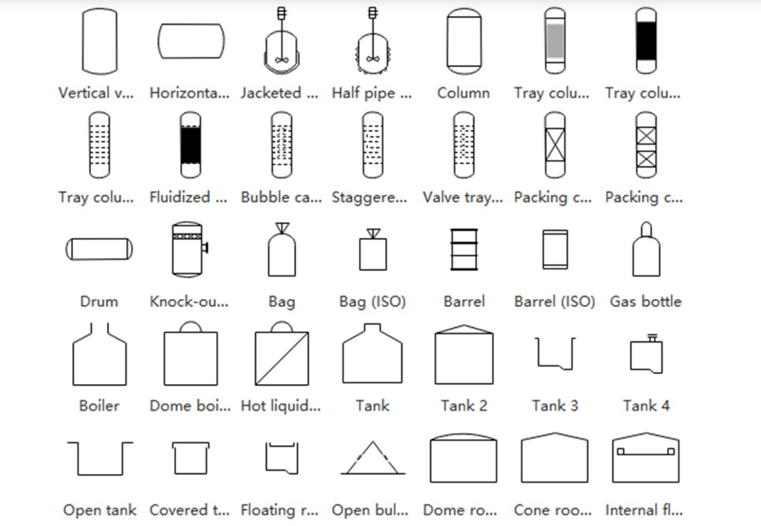

Fig. 4. **Tank symbol**

### **4.4 Heat exchanger**

Heat is transferred from various mediums or places using heat exchangers.

Boilers, condensers, hose reels, and a wide variety of other pieces of equipment are included in this category.

Fig. 5. **Heat Exchanger symbol**

### **4.5 Pump**

A pump is a broad term for a category of equipment that utilizes pressure to compress or push fluids and cause them to travel along a pipeline. Pumps are often utilized in both daily life and business.

Pumps, fans, nozzles, and other items fall under this category.

Fig. 6. **Pumps symbol**

### **4.5 Measuring Device**

Instrumentation is used to test and monitor fluid amounts in various system components, including flow, temperature, pressure, and others. The symbols in the P&ID drawings will denote the kind of equipment being used as well as where it is installed.

The measuring, processing, and display equipment falls under this category.

Fig. 7. **Instrumentation symbol**

### **4.6 Valve**

Valves are used to open or close passageways in a pipe system to regulate the flow of fluids. We must select a suitable sort of valve based on the fluid that the pipeline is carrying.

Hand valves, solenoids, one-way valves, multi-port valves, etc. are included in this component.

Fig. 8. **Valve symbol**

# Discussion

**Project Specification:**

Fig. 1. **P&ID of a wastewater treatment plant**

• All items on the P&ID are to be displayed over 3 separate HMI screens, labelled 1,2, & 3 as shown above in the yellow sections and shall nave the following features. Navigation links between screens based on the layout and position.

• Agitators

o Every agitator should have a start and stop button.

o Activated only if source not empty, otherwise DISABLED.

o Animated, indicating status: Inactive, running, disabled.

• Pumps

o Every pump should have a START and STOP button.

o Activated only if source not empty and destination not full, otherwise DISABLED

o Animated, indicating status: Inactive, running, disabled.

• Tanks

o Tanks to have current level and total capacity shown.

o Tanks to display an animated derived digital indication when tank is at high or low level.

o Tank levels should slowly decrease to minimum if pump is pumping out.

o Tank Levels should slowly increase to maximum if pump is pumping on.

• Other requirements.

o All editable, to be validated with intuitive human readable warning messages

For example: For tank volume – Ensure VAL > 0, VAL<TANK_CAPACITY

o All pumps, motors and rotors are discrete employing on/off control only.

o All code fully documented, correctly Labelled and written for readability / maintainability.

o All numeric fields, for testing purposes, are to be editable (including tank capacities).

**Installed software**

Totally Integrated Automation Portal

Version V15.1 Update 5

STEP 7 Professional

Version V15.1 Update 5

WinCC Advanced

Version V15.1 Update 5

1. **SIMATIC S7-1200: The Modular Mini-PLC**

Fig. 9. **SIMATIC S7-1200: The Modular Mini-PLC**

**Features**

• Modular compact control system for the low-end performance range

• Scaled CPU range

• Extensive range of modules

• Can be expanded to up to 11 modules (depends on the CPU)

• Can be networked with PROFIBUS or PROFINET

• Slot rules

− CM left of the CPU (number depends on the CPU)

− SM right of the CPU (number depends on the CPU)

• "Total package" with CPU and I/O in one device

− integrated digital and analog I/O

− an expansion with signal board

• "Micro PLC" with integrated functions

Fig. 10. **SIMATIC S7-1200: Modules**

**Slot Rules**

• CM left of the CPU (number depends on the CPU)

• Signal modules (digital, analog) right of the CPU (number depends on the CPU)

Signal Modules

• Digital input, output or mixed modules (24VDC, relay)

• Analog input, output or mixed modules (voltage, current, resistance, thermocouple)

Communication Modules (CM - Communication Module, CP - Communication Processor)

• Point-to-point connection (RS232, RS485)

• PROFIBUS

• ASi-Master

• Telecontrol (GPRS functionality)

Expansion Board

With this the CPU can be expanded by onboard I/O or an interface.

A battery board ensures the long-term battery backup (buffering) of the real-time clock.

1. **TIA Portal: Portal View and Project View**

**Portal View**

• Task-oriented mode of working

• Fast project entry with user guidance

**Project View**

• Hierarchical structuring of the project

• The necessary editors open according to the task in hand

**Project Navigation (Tree)**

The Project tree contains all components and project data of an automation solution. All

components can be opened from there.

**Working Area**

The objects opened for editing are displayed in the working area. These objects include, for

example hardware components, blocks, PLC tag tables, screens of HMI devices etc. If several

objects are open at the same time; they are displayed as tabs in the task bar.

**Task Cards**

These provide tools for configuring/programming. The content of the Task cards depends on the object displayed in the working area.

If a hardware station is open, the Hardware catalog, for example, is available as a Task card.

If a program block is open, there is a Task card with Instructions.

**Inspector Window**

Additional information on a selected object or on executed actions is displayed in the Inspector window. The available properties of the selected objects can also be edited here (for example, properties of screens, screen objects, tags).

The Inspector window displays all system messages from the engineering, for example, those resulting from generating a project. This window should always be checked for any errors and warnings after a generation is completed.

**Details View**

The Details view is a help window. Here, the elements of the configuration object selected in the Project tree are displayed. These can be used in the active working area (by dragging them to the working area using drag & drop). This enables fast access to the required objects (for example, tags).

**Project Tree**

The "Project tree" window provides access to all components and project data. All components

and all available objects of a project appear in the Project tree in a tree structure and can be

opened from there by double-clicking on them.

The following actions can be carried out:

• adding new components (controllers, HMI devices etc.)

• editing existing components

• querying and modifying properties of existing components

• diagnosing accessible components

To improve clarity, objects (entire stations or blocks of a station) can be grouped together.

Fig. 11. **Standard IEC 61131 languag**Diagram

Description automatically generated**es associated with PLC programming.**

## 

Conclusion

1. HMI Portion

* **Screen 01**

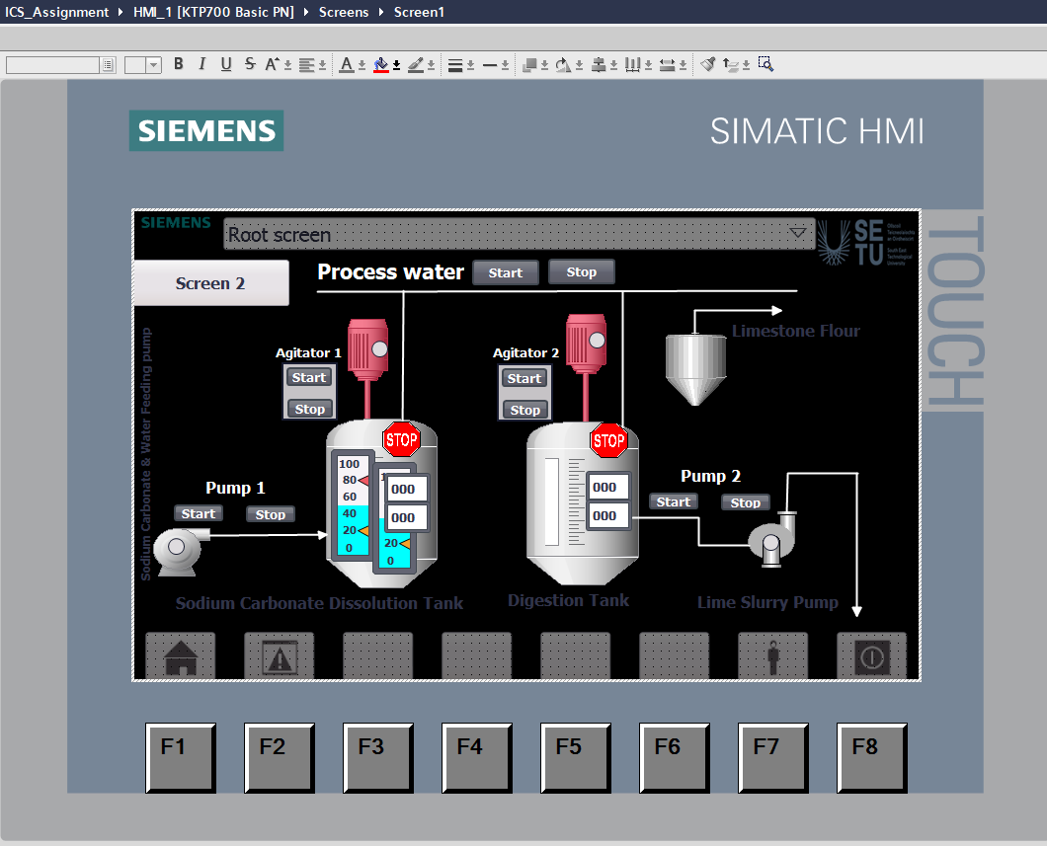

* **Screen 02**

* **Screen 03**

1. PLC Portion

Organization Block (OB): The main programming block that incorporate networks and components that drive specific tasks. More discussions later.

Function block (FB): Create function blocks. More discussions later.

Function (FC): A subroutine that perform a specific task, this block is called by the organization block.

Data block (DB): An archive where a different set of tags and data are stored; it is used with functions.

A brief insight on what functions or subroutines are:In STEP7 programming, a function call has programs written in it, very much like an Organization Block. However, the function will not be executed unless it is called by an organization block. When called, the function will execute all its programs or tasks, then return control to the organization block.

Demonstration can be seen below:



Creating a function

1. On the left panel, drop down program blocks.

2. Double click add new block.

3. Name it Start01/Stop01RealIOBlock.

4. Click Ok.

5. Repeat these steps but name the function HMIRideControl11 and number it 11.

6. Now that you got your functions created, go double click on Main [0B1].

7. Minimize all your networks, as shown, next hold CTRL and left click all the networks. Right click and cut.

8. Next, double click on the Start01/Stop01RealIOBlock on the left panel and paste the networks into it.

9. Your Main [OB1] should be blank and the Start01/Stop01RealIOBlock should have the networks.

10. Next, drag Start01/Stop01RealIOBlock to network 1 of your Main [OB1]

11. Next, navigate back to Main [OB1] then drag HMIRideControl11 block to network 1.

12. Save, download, and test your program.

Lab 3: Data Block

Last lab we studied the function in programming blocks. This is lab, we will study another program block called the Data Block.

We use the data block to organize tags. All tags are stored in the PLC tags drop down, this can get very confusing if your program is large. As mentioned in the previous lab, Data block works with the function.

1. Create a data block and name it HMIStartStopDB11, select manual and choose number

11. If you have done it correctly, there should be a blank page of tags.

**Bool** – a byte, on or off

**Int – a number 2 bytes**

**Dint** – double integer, a word, 4 bytes

**Time** – a special data type that holds time

2. Now fill out your data block as shown.

3. Once that’s complete, double click Start01/Stop01RealIOBlock and COPY all of its networks.

4. Paste the networks into HMIRideControlFC11.

5. Now, open HMIRideControlDB11 and float the window, to reveal HMIRideControlFC11 and HMIRideControlDB11.

6. Update the all the contacts in HMIRideControlFC11 by dragging the tags from HMIRideControlDB11 to the respected contacts.

7. Save and Download the PLC and monitor.

8. Float the DB11 window while the PLC is running. Here, you should be able to see TimerValue11 increasing (in Miliseconds), the RideCount11 incrementing, and the RideDollar11 increasing

9. When done, go offline and save.

# References

[1] Real Group. (2020). Sơ đồ đường ống và thiết bị đo (P&ID). [online] Available at: https://www-real--group-org.translate.goog/so-do-duong-ong-va-thiet-bi-do-pid/?_x_tr_sl=auto&_x_tr_tl=en&_x_tr_hl=en&_x_tr_pto=wapp [Accessed 18 Dec. 2022].

[2] Siemens (n.d.). *TIA Portal Documentation LAB 2* [Accessed 18 Dec. 2022].

[3] siemens.com Global Website. (n.d.). *SITRAIN – Digital Industry Academy*. [online] Available at: https://www.siemens.com/global/en/products/services/digital-enterprise-services/training-services/sitrain.html [Accessed 17 Dec. 2022].

‌

‌

‌‌‌

## 

## Appendices

## Appendix 1: Drawings and schematics

* P&ID

## 

## Appendix 2: Software

* HMI

## 

## Appendix 3: Hardware

-PLC

